Website Project Proposal
Website Name: CANNHealth.ca
Who we are?
CANNHealth.ca is a market place for Medical Marihuana in Canada. We provide our users (licensed producers, licensed distributors and registered Medical Marihuana patients with a wide range of the finest quality medical grade cannabis products to choose from and purchase based on their specific needs.
Our website users:
- Licensed Producers/Licensed Distributors: CANHealth.ca is the place to buy and sell Marihuana for Medical Purposes. Licensed Producers/ Distributors are able to upload their inventory of products to either sell to other producers or distributors or Registered Medical Marihuana Users.
- Registered Medical Marihuana Users: CANHealth.ca offers a range of Cannabis solutions for Medical Marihuana Users from the inventory of products listed by their licensed producer’s partners.
Website Requirements:
Important Note: Page content will be specific depending on the type of user. Example: If you are a Licensed Producer/ Distributor or if you are a Registered Medical Marihuana User.
- Landing Page:
- Landing page objective is to direct visitors to appropriate page based on specific user category:
Note: We could have a background picture and CANHealth.ca logo and the below message displaying-
Are you a Licensed Producer/Distributor? Click Here
Are you a Registered Medical Marihuana User? Click Here
- Licensed Producer/Distributor Page View and requirements:
Main Menus: (Highlighted in Yellow)
- About Us-Content to be developed
- Register- This category will have the following Sub-menus: SIGN UP-LOG IN- MANAGE YOUR PRODUCTS/TRANSACTION HISTORY (Highlighted in purple)
- SIGN UP: Please create the following standard form for new licensed producers/distributors:
- Licensed Producer Name
- Main Contact
- Website (if applicable)
- Phone number
- Fax number
- Address
- Email address
- Field to upload/browse mandatory documents that will be available for review and validation from CANHealth.ca Compliance Team-
- Message will display after all fields have been completed: Thank you for submission. We will confirm your registration within 2 business days.
- CANHealth.ca team receives e-mail requesting validation of Registration.
- Registrant will receive e-mail from CANHealth.ca within 2 business days to confirm registration and provide Login Access information: User Name, Unique User ID Code and temporarily password. User must be able to enter new password next time he/she logins. (Can system generate automatic user name and password? Can we incorporate validation process from CANHealth.ca within the system rather than completing any tasks outside the website?)
- LOG IN: Access to users that have received confirmation of registration.
- MANAGE YOUR PRODUCTS: This field will allow licensed producers/distributors to upload their inventory information as follows:
- Standard Mandatory Form to be completed by user. All fields on this form are mandatory:
-Product Name:
-Product Description:
-Product recommended for the following conditions:
-CBD Level:
-THC Level:
-Taste/Flavour:
-Price per gram:
-Upload Image of product:

- TRANSACTION HISTORY: This field will allow user to generate reports on their transactions. Type of reporting to be determined based on specific user requirements.
- Products-Available Inventory from Licensed Producer/Distributor will be displayed including BUY NOW button.
- Product Display Format:
Please provide design enhancement- See example below for information. Design must be definitely improved.

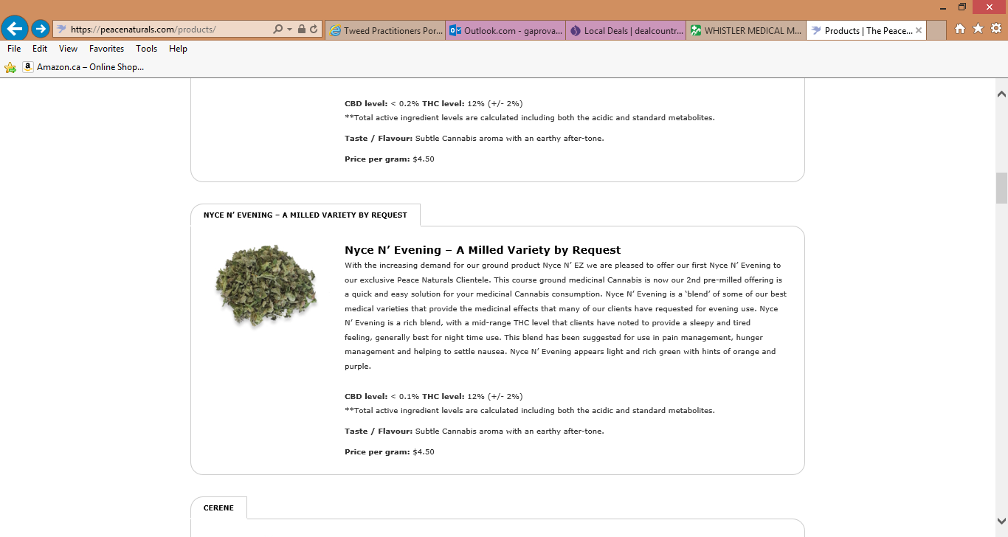

- Doctors- Content to be developed
- FAQ- Specific for Licensed Producer/Distributor
- Contact us-

- Registered Medical Marihuana User Access and Requirements:
Main Menus: (Highlighted in Yellow)
- About Us-Content to be developed specifically for Medical Marihuana Users
- Register- This category will have the following Sub-menus: SIGN UP/LOG IN/ ORDER HISTORY (Highlighted in purple)
- SIGN UP: Please create the following standard form for new Registered Medical Marihuana Users:
- First Name
- Last Name
- Phone Number
- Address
- Email address
In order to proceed with your registration, CANHealth.ca must receive the following documents:
1) The original CANHealth.ca New Client Registration Form (A, B or C) signed and dated.
2) The original Medical Document signed and dated by your Health Care Practitioner. (We are unable to accept a copy)
3) A completed copy of the Consent to Disclose Personal Health Information.
Your completed documents must be sent to the following mailing address:
MAILING ADDRESS TO BE INCLUDED
Note: All these DOWNLOADABLE FORMS to be created and available under FORMS Menu.
New Client Registration Form A: For clients with a permanent residence. Click here to download.
New Client Registration Form B: For clients who do not have a permanent residence. (I.e., if you live in a nursing home, shelter, hostel or other similar institution in Canada) Click here to download.
New Client Registration Form C: For clients who would like their medicine delivered to their Health Care Practitioner’s office. Your Health Care Practitioner must first agree to receive medicine on your behalf. Click here to download.
Medical Document: To be completed, signed and dated by your Health Care Practitioner. We must receive the original signed version. Click here to download.
Consent to Disclose Personal Health Information: A copy of this form is to be retained by your Health Care Practitioner and a second copy must be sent to CANHealth.ca. Click here to download.
CANHealth.ca team receives e-mail notifying a new registrant has set up a profile.
- Registrant will receive e-mail from CANHealth.ca confirming validation of registration once all original documents are received and approved. Login Access information: User Name, Unique User ID Code and temporarily password to be included in communication. User must be able to enter new password next time he/she logins. (Can system generate automatic user name and password? Can we incorporate validation process from CANHealth.ca within the system rather than completing any tasks outside the website?)
- LOG IN: Access to users that have received confirmation of registration.

- ORDER HISTORY: This field will allow user to view orders including product type, date ordered, amount, price, etc.
- Products-Available Inventory will be displayed including BUY NOW button.
- Product Display Format:
Please provide design enhancement- See example below for information. Design must be definitely improved.

- FORMS: PDF Fillable Forms Listed under this menu.
- - Content to be developed
- FAQ- Specific for Licensed Producer/Distributor
- Contact us-

MANDATORY REQUIREMENT: MEDICAL USERS ARE ONLY ALLOWED TO PURCHASE A CERTAIN AMOUNT. THE SYSTEM MUST BE CAPABLE TO TRACK MEDICAL USERS TRANSACTIONS AND STOP TRANSACTIONS WHEN IF THE LIMIT WILL BE EXCEEDED. I GUESS A MESSAGE WILL COME FROM THE BUY NOW AND WILL DIRECT THE USER TO THE ORDER HISTORY PANEL.
Action Plan:
Next Steps:

- Toronto Hispano to evaluate proposal and clarify information with CANHealth.ca
- Toronto Hispano to provide project evaluation including price and timeliness
- Toronto Hispano to create logo for CANHealth.ca
- Toronto Hispano to provide preliminary website design proposal
- Toronto Hispano to report programming requirements and specs
- CANHealth.ca will work on website content: FAQs, About US, Contact, etc.

